Project Design Phase-II
Technology Stack (Architecture & Stack)

Date | 5 September 2026
Team ID | SWUID2026190376
Project Name | Metro Ticket Generating System in ServiceNow
Maximum Marks | 4 Marks

Technical Architecture:
The Deliverable shall include the architectural diagram as below and the information as per the table1 & table 2
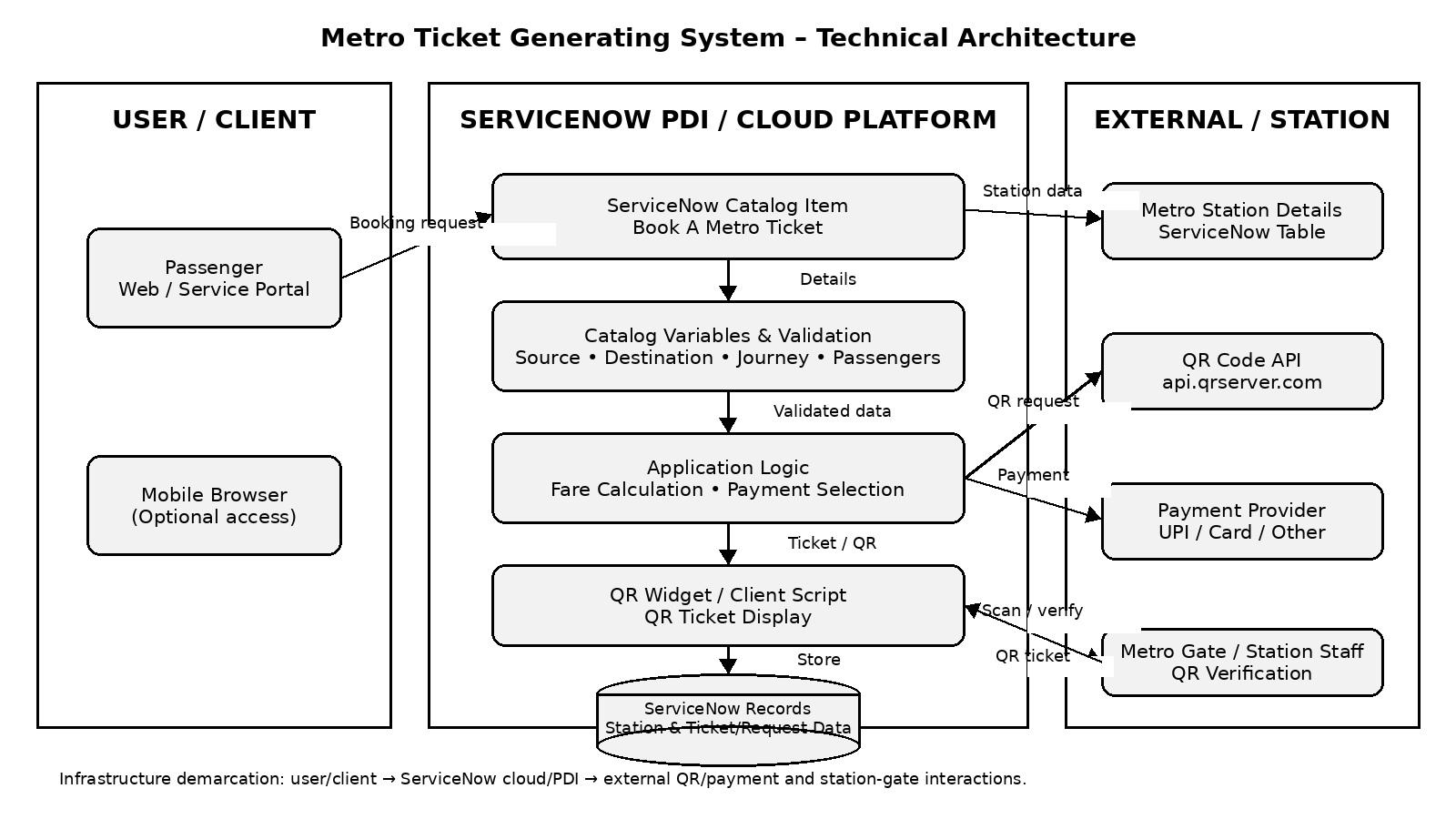
Example: Metro Ticket Booking and QR Ticket Generation
Project-specific architecture prepared for the Metro Ticket Generating System.
Guidelines:
Include all the processes (As an application logic / Technology Block)
Provide infrastructural demarcation (Local / Cloud)
Indicate external interfaces (third party API’s etc.)
Indicate Data Storage components / services
Indicate interface to machine learning models (if applicable)


Table-1 : Components & Technologies:
S.No | Component | Description | Technology
1 | User Interface | Interface used by passengers to book metro tickets and view the QR ticket. | ServiceNow Service Portal / Catalog UI, HTML, CSS, JavaScript
2 | Application Logic-1 | Ticket booking form processing and field validation. | ServiceNow Catalog Item & Catalog Client Script
3 | Application Logic-2 | Automatic fare calculation based on journey and passenger details. | ServiceNow Client Script / JavaScript
4 | Application Logic-3 | QR ticket display and ticket interaction. | ServiceNow Portal Widget, AngularJS, JavaScript
5 | Database | Stores metro station details and ticket/request information. | ServiceNow platform tables / database
6 | Cloud Database | Cloud-hosted data storage provided by the ServiceNow platform. | ServiceNow Cloud Database
7 | File Storage | No separate file-storage service is required for the core solution. | ServiceNow platform storage / configuration records
8 | External API-1 | Generates the QR image used for the digital metro ticket. | QR Server API (api.qrserver.com)
9 | External API-2 | Payment processing interface represented by the selected payment mode. | UPI / Card / Other payment interface
10 | Machine Learning Model | No machine learning model is required for the current project. | Not Applicable
11 | Infrastructure (Server / Cloud) | Hosts the catalog item, scripts, widget, tables and project configuration. | ServiceNow PDI / Cloud Platform

Table-2: Application Characteristics:
S.No | Characteristics | Description | Technology
1 | Open-Source Frameworks | The solution uses standard web scripting and ServiceNow portal technologies; no separate open-source application framework is required. | HTML, CSS, JavaScript; ServiceNow Portal/Widget framework
2 | Security | Access to project records is controlled using ServiceNow access-control mechanisms. The solution does not require storing payment credentials in the custom tables. | ServiceNow ACLs / roles / platform security
3 | Scalable Architecture | The solution separates the user interface, catalog/application logic, QR integration and data storage components, allowing additional stations and ticket records to be supported. | ServiceNow platform architecture
4 | Availability | The application is delivered through the ServiceNow platform and is available when the ServiceNow instance and required services are operational. | ServiceNow cloud/PDI platform
5 | Performance | The design keeps booking logic lightweight, uses client-side validation/calculation where appropriate, and generates the QR image through an external API. | JavaScript, ServiceNow Catalog, QR API

References:
https://c4model.com/
https://developer.ibm.com/patterns/online-order-processing-system-during-pandemic/
https://www.ibm.com/cloud/architecture
https://aws.amazon.com/architecture
https://medium.com/the-internal-startup/how-to-draw-useful-technical-architecture-diagrams-2d20c9fda90d

